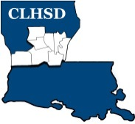
Central Louisiana Human Services District
Board Meeting Agenda
March 9, 2023

- Call to Order/Quorum
- Prayer/Pledge

- Read and Approve March 2023 Meeting Agenda
Solicit Public Comment Requests

- Approval of February 2023 Minutes

- District Reports

  - Financial Report- H1
  - ED Monthly Report H2
- Board Business
A. Welcome new board member, Jennifer Lofton

B. Complete and Communicate Performance Evaluation of the ED
- Board will go into executive session
- Come out of Executive Session - Motion and Vote

- Questions/Comments as Solicited

- Next Month
- Policy Reviews – Executive Limits
- II.H. Compensation and Benefits – Rebecca Craig
- II.K. Community Relationships – Rebecca Craig
- Board Development/Training Topic - Contracts
- Tier 2.1 – Covering Calendar Year 2022 due by May 15th
- Annually Ethics training for the current year to be completed by the May meeting

- Questions/Comments As Solicited

- Announcements
- Next meeting is April 6, 2023
- Adjourn (Vote)

- Adjourn Board Meeting

